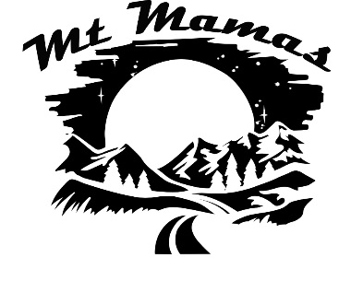

**Starter Pack**

**Mt Biking**

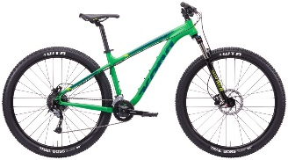

**Helmet**

**Mt Bike**

* Snug fit around head and easy adjustment
* Easy chin strap adjustments
* Full coverage low on the back of the head
* Pricey helmets have “Rotational Impact Protection Systems” (MIPS/SPIN)

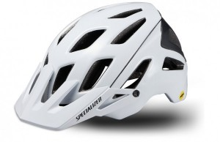

* Hard Tail (front suspension)
* Full Suspension (front/back suspension)
* 29” tires is the new thing-easier to ride over junk and better grip
* Get good components (brakes, shifters, derailers, shocks): Shimano, SRAM, Fox, RockShocks
* Get fitted in a bike shop regardless of where you buy

**Brands: Specialized, Smith, Bell, Fox**

<https://www.outdoorgearlab.com/topics/biking/best-mountain-bike-helmet>

**Brands: Cannondale, Scott, Giant, Specialized, Kona, Trek, Ibis, Santa Cruz**

<https://www.outdoorgearlab.com/topics/biking/best-mountain-bike>

**Bike Pump/Kit**

**Gloves**

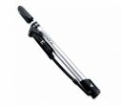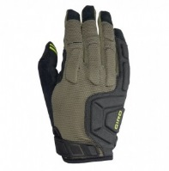

**Brands: Pumps – Topeak, Lezyne; Kits -Crankbrothers, Bikehand**

* Full finger provides more protection
* Fit is important
* Padding on knuckles

<https://www.outdoorgearlab.com/topics/biking/best-frame-pump>

[https://saferoad.org/best-bicycle-tool-kit/](https://saferoad.org/best-bicycle-tool-kit/%20)

**Brands: Giro, Dakine**

<https://www.outdoorgearlab.com/topics/biking/best-mountain-bike-gloves>

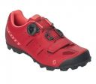

* Velcro vs Laces
* Solid soles for more power transfer
* Clipless better for new riders

**Shoes**

**Brands: Pearl Izumi, Giro, Ride**

<https://www.outdoorgearlab.com/topics/biking/best-mountain-bike-shoes-womens>