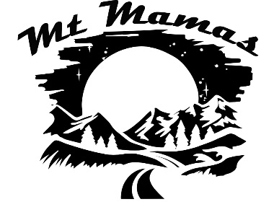

**Starter Pack**

**Cross Country Skiing**

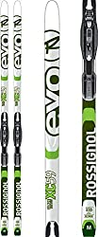 **Cross Country Skiis**

* Longer than downhill skiis
* Classic/Touring – great for beginners
* Skate – more cardio, uphill, groomed trails
* Backcountry – shorter, better for deep snow
* Beginners need more flexible skiis
* Waxless easier for beginners; Wax more versatile

**Brands: Rossignol, Fischer, Salomon, Atomic**

<https://theskigirl.com/best-cross-country-skis/>

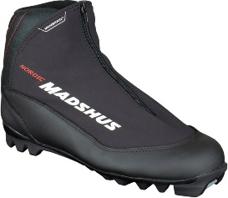

**Poles**

**Boots**

* Longer and lighter than downhill ski poles
* Classic – reach your armpits
* Skate – up to nose or lips
* Adjustable hand straps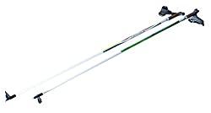



* Classic/Touring – mobility/flexibility are important; cover up laces; rings for gaiters to attach
* Skate – lighter, lower ankles
* Backcountry – stiff, higher ankles, beefier
* Make sure boots and ski bindings match

**Brands: Rossignol, Salomon, Fischer, Alpina**

[https://www.theadventurejunkies.com/best-cross-country-ski-boots/](%20https:/www.outdoorgearlab.com/topics/shoes-and-boots/best-winter-boots-womens)

**Brands: Fischer, Rossignol, Winget**

[https://theskigirl.com/best-cross-country-ski-poles/](%20https:/www.outdoorgearlab.com/topics/shoes-and-boots/best-winter-boots-womens)