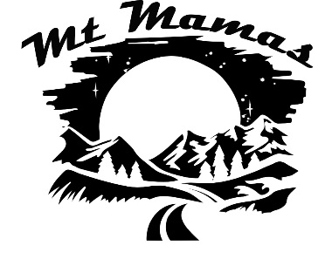

**Starter Pack**

**Rock Climbing**

**Indoor**

**Harnesses Shoes**

* Tight, but not too tight (I like old rentals)
* Velcro slippers for indoor or short routes

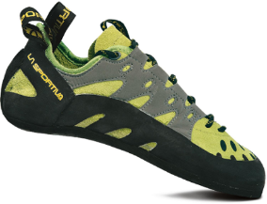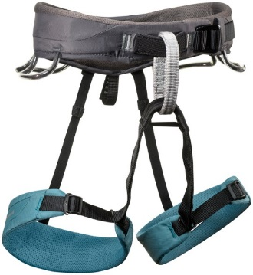

* padded waist and legs
* gear loops
* automatic “double-back” buckle
* chalk bag loop at back

**Brands: La Sportiva, 5.10, Scarpa, Boreal**

[**https://www.outdoorgearlab.com/topics/climbing/best-climbing-shoes-womens**](https://www.outdoorgearlab.com/topics/climbing/best-climbing-shoes-womens)

**Brands: Petzl, Black Diamond, Singing Rock, REI**

[**https://www.gearx.com/blog/knowledge/climbing/how-to-choose-a-climbing-harness/**](https://www.gearx.com/blog/knowledge/climbing/how-to-choose-a-climbing-harness/)

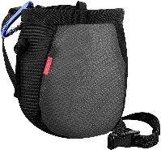

**Chalk Bag**

* any cool looking one 😊 with small carabiner to clip onto back of harness or use a clip belt
* fill chalk bag ball with loose white chalk
* cheap at gear swaps

**Outdoor**

**Dynamic Rope Quickdraws**

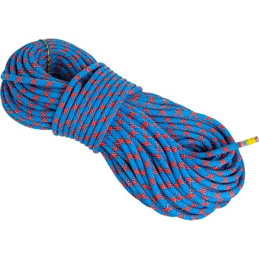 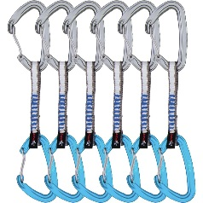

* 12 will be sufficient for most outdoor routes (or share 6 with your buddy)
* 9 + mm
* 60 meters
* dry sheath
* 2 separate patterns for each half of rope (easy to find center)

**Brands: Petzl, DMM, Black Diamond**

[**https://www.outdoorgearlab.com/topics/climbing/best-quickdraw**](https://www.outdoorgearlab.com/topics/climbing/best-quickdraw)

**Brands: Beal, Black Diamond, Sterling, Edelrid**

[**https://www.outdoorgearlab.com/topics/climbing/best-climbing-rope**](https://www.outdoorgearlab.com/topics/climbing/best-climbing-rope)

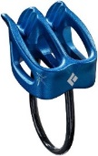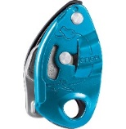 **Locking Carabiner**

**Belay Device**

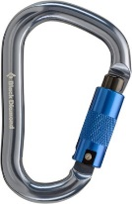

* 1 (for belay device)
* 4 more if you want to use for anchors with slings (or you can use 2 quickdraws if the route is short)

**ATC -XP**

**Gri-Gri**

* ATC-XP – great for lead climbing, ridges for more friction, can single-rope rappel
* Gri-Gri – great for beginners or if climbing partner is heavy or takes along time on climbs (kids)

**Brands: Black Diamond ATC, Petzl Gri Gri**

[**https://www.outdoorgearlab.com/topics/climbing/best-belay-device**](https://www.outdoorgearlab.com/topics/climbing/best-belay-device)

**Brands: Petzl, Camp, DMM, Edelrid**

[**https://www.outdoorgearlab.com/topics/climbing/best-locking-carabiner**](https://www.outdoorgearlab.com/topics/climbing/best-locking-carabiner)

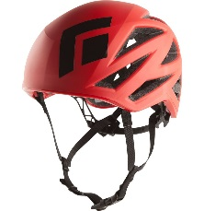

* Snug fit around head and easy adjustment
* Easy chin strap adjustments

**Brands: Petzl, Black Diamond, Mammut**

<https://www.outdoorgearlab.com/topics/climbing/best-climbing-helmet>

**Helmet**