

**Starter Pack**

**Camping**

**Tent Sleeping Bag**

* **Down –**

Pros: warm, packs small, lightweight

Cons: becomes cold when wet, price

* **Synthetic –**

Pros: warm when wet, great for young kids

Cons: heavier, colder

* Cold rating – 10-20 degrees less than what you want
* Lightweight/durable material
* Rainfly with Vestibule (area outside tent for putting packs and muddy boots)
* Two doors for ventilation
* Shorter the tent, the warmer

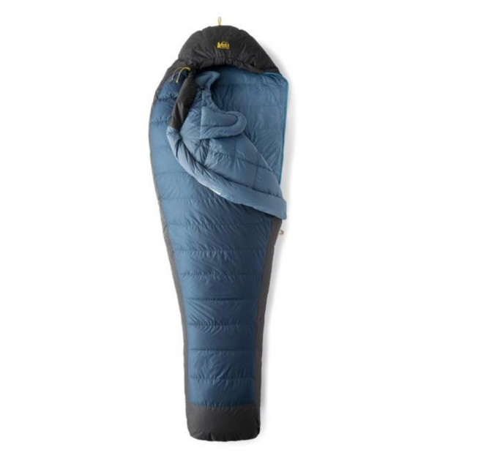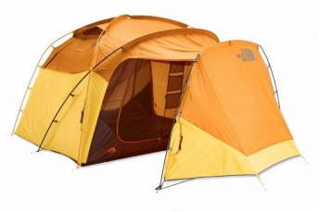

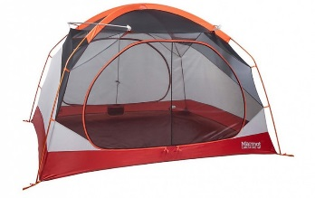

**Brands: REI, Big Agnes, Marmot, North Face**

[https://www.outdoorgearlab.com/topics/camping-and-hiking/best-camping-tent](https://www.outdoorgearlab.com/topics/camping-and-hiking/best-camping-tent%20)

**Brands: Kelty, Marmot, Western Mountaineering, Big Agnes, REI**

<https://www.outdoorgearlab.com/topics/camping-and-hiking/best-backpacking-sleeping-bag>

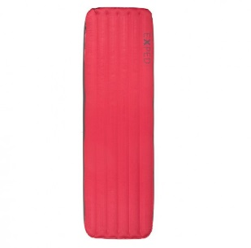

**Sleeping Pad**

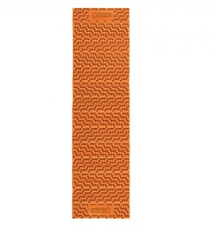

**Brands: Thermarest, Big Agnes, Klymit, REI, Sea to Summit**

<https://www.outdoorgearlab.com/topics/camping-and-hiking/best-sleeping-pad>

* **Closed Cell** – Lighter, need to inflate with breath, warmer, packs smaller
* **Open Cell** – Heavier, colder, no inflation, folds like accordion
* Cover material may be slippery or soft

**Open Cell**

**Closed Cell**