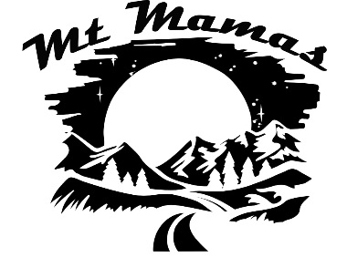

**Starter Pack**

**Snowshoeing**

**Winter Boots**

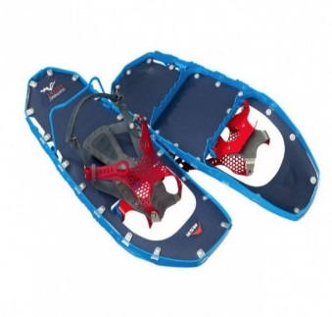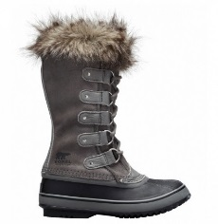 **Snowshoes**

* Full rubber lower boot
* Good fit but not too tight if you need extra socks for warmth
* Traction for icy trails
* Tall enough to keep snow out or use Gaiters/Overboots up to your knees

* **MSR –** Metal ridges help on ice and steep slopes
* **Tubbs/Atlas –** Good floatation on snow
* Wear with waterproof boots or overboots

**Brands: Oboz, Sorel, Columbia, UGG** [https://www.outdoorgearlab.com/topics/shoes-and-boots/best-winter-boots-womens](%20https:/www.outdoorgearlab.com/topics/shoes-and-boots/best-winter-boots-womens)

**Brands: MSR, Tubbs, Atlas**

<https://www.outdoorgearlab.com/topics/snow-sports/best-snowshoes>

**Gaiters/Overboots**

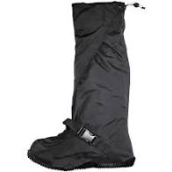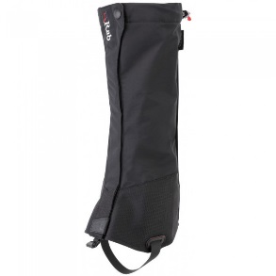

**Poles**

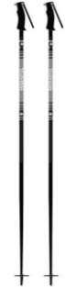

* Carbon or Aluminum shaft
* Adjustable if going in the backcountry
* Sizing – with hands on grips arm should be a 90 degree angle

**Overboots**

**Gaiters**

* Up to knee if possible
* **Gaiters** – wear over waterproof low boots
* **Overboots** – wear over sneakers

**Brands: Fischer, Rossignol, Volkl, Leki**

<https://www.switchbacktravel.com/best-ski-poles>

**Brands: Outdoor Research, Black Diamond, RAB**

<https://www.outdoorgearlab.com/topics/climbing/best-gaiters>