

**Starter Pack**

**Canoeing**

**Canoe Life Jacket (PFD)**

* **Buy** cost $900-3000
* **Rent** –
* **BYU Outdoor**
* **UVU Outdoors Unlimited**
* **U of U Outdoor**  **Adventures**

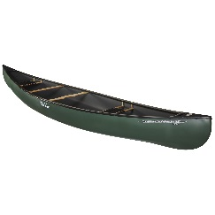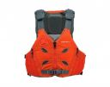

* Tapered front
* Multiple side straps for adjustment
* Pockets
* Rent with canoe

**Brands: Old Town, Nova Craft**

**https://paddlingmag.com/boats/best-canoes/**

**Brands: Astral, NRS**

<https://www.outdoorgearlab.com/topics/paddling/best-pfd>

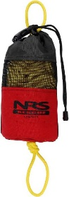

**Throw Bag**

**Paddles**

* Plastic/Aluminum- cheap/light
* Wooden-strong/heavy
* Carbon fiber-expensive/light
* Rent with canoe

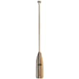

* Bright color
* Foam insert
* 50-75 ft

**Tow Rope**

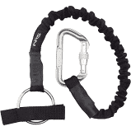

* To tow other canoes or swimmers

**Brands: Werner, NRS, Carlisle, Bending**

[**https://sportconsumer.com/best-canoe-paddles/**](https://sportconsumer.com/best-canoe-paddles/)

**Brands: NRS, Level Six, Huck**

[https://paddlingmag.com/gear/best-throw-and-tow-bags/](https://paddlingmag.com/gear/best-throw-and-tow-bags/%20)