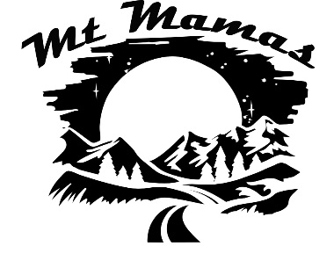

**Starter Pack**

**Rafting**

**Raft Life Jacket (PFD)**

* **Buy** cost $5000+
* **Rent** –
* **BYU Outdoor** (2/6/8/10 person)
* **UVU Outdoors Unlimited** (2/6 person)
* **U of U Outdoor** Adventures (6/8 person)

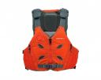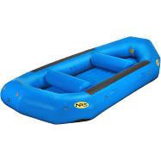

* Tapered front
* Multiple side straps for adjustment
* Pockets
* Rent with raft

**Brands: Astral, NRS**

<https://www.outdoorgearlab.com/topics/paddling/best-pfd>

**Brands: NRS**

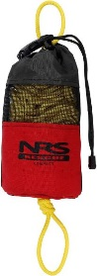

**Throw Bag**

**Paddles**

* 62-66” depending on height
* Longer paddles for guide (red)
* Rent with raft

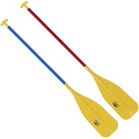

* Bright color
* Foam insert
* 50-75 ft

**Brands: NRS, Level Six, Huck**

[https://paddlingmag.com/gear/best-throw-and-tow-bags/](https://paddlingmag.com/gear/best-throw-and-tow-bags/%20)

**Brands: NRS, Sawyer**

[**https://www.raftingmag.com/rafting-magazine/basic-paddle-selection**](https://www.raftingmag.com/rafting-magazine/basic-paddle-selection)