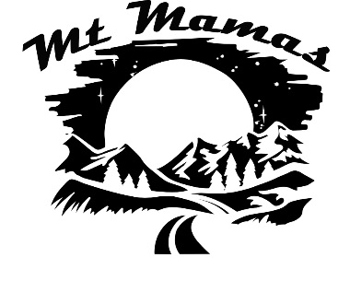

**Starter Pack**

**Downhill Skiing**

**Downhill Skiis**

* Carbon or Aluminum shaft
* Adjustable if going in the backcountry
* Sizing – with hands on grips arm should be a 90 degree angle
* As tall as your height, shorter - beginners, longer – experienced
* 3 measurements mm– tip/waist/rear
* Carving skiis– narrow, <80 mm waist, groomed runs
* Powder skiis– wider, 110 mm+ waist
* All-Mountain skiis – combo
* Rocker – tips of skis, makes for better turning
* Bindings are important – Salomon, Marker, Rossignol Tyrolia

**Poles**

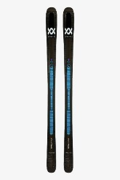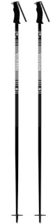

**Brands: Fischer, Rossignol, Volkl, Leki**

<https://www.switchbacktravel.com/best-ski-poles>

**Boots**

**Brands: Rossignol, Fischer, Salomon, Atomic, Volkl, Nordica, Head, K2**

<https://www.switchbacktravel.com/best-skis-beginners>

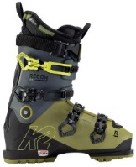

* Flex- 50-140, beginners do better with lower number with more flex
* Sizing (Mondo) – cm toe to heel, snug but not tight
* Last (width) – mm side to side, avg 100 mm
* Liners – softer for beginners, heat-moldable liners for custom fit

**Helmets**

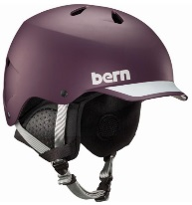

* ABS construction – durable, cheap, hard plastic shell with foam liner glued
* Ventilation – with adjustment
* Liner helps with warmth – covers ears
* MIPS liner protects in impact
* Goggle clip on the back
* Audio compatability

**Brands: Lange, Tecnica, Salomon, Atomic, Nordica, K2**

<https://www.switchbacktravel.com/best-ski-boots-beginners>

**Brands: Smith, Giro, Oakley**

[**https://www.switchbacktravel.com/best-ski-helmets**](https://www.switchbacktravel.com/best-ski-helmets)

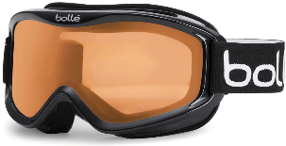

* Cylindrical – cheap, some glare vs Spherical
* Mirrored Lenses decrease brightness
* Visible Light Transmission (VLT) as high as possible
* Good ventilation prevents fogging
* Make sure there is as little gap between top of goggles and helmet

**Goggles**

**Brands: Giro, Smith, Bolle, Oakley**

<https://www.switchbacktravel.com/best-ski-goggles>